How to use –

1. Enter format in Format box.
2. Enter text into TextToConvert box
   1. Click on button “Convert Text”. Text will be displayed in below section.

Web application screenshot for CSV Format

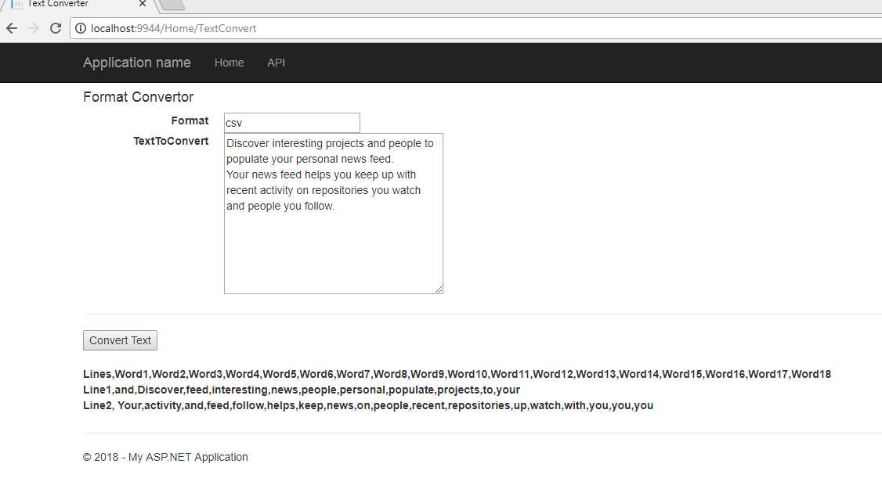

Web application screenshot for XML Format

